**Campus Placement Management**

**Chapter-1**

**Study of Existing system and system requirements.**

**Hardware & Software Requirement:**

**Hardware Interfaces**

* Minimum Hardware requirement
* Processor: P4 3.0 GHz
* RAM:1 GB or Higher
* Monitor
* Mouse
* Hard disk: 80 GB

**Software Interfaces**

* Minimum Software requirement
* Java (JSP and Servlet)
* Apache Tomcat Server

All these types of software automatic configure inside operating system after installation it having Java, MYSQL, Apache and operating system base configuration file, it doesn’t need to configure manually.

Introduction

As we know, Campus Placement Cells plays an important role in Colleges for students to provide them a platform to get their first dream job and to kick off their careers. This is a Java project built in the same way to manage the Campus Placement Activity through a portal. This project is designed to help students in planning their career and it will help the students to apply to the job where they fit in.

Admin here is the main user of this application, who will add Company, add Jobs, Create Job Report, etc. The admin is responsible for adding the functionality. Now, we have another user who is the students who are going to apply for the respective Jobs. Students just need to register over the site and then can take the advantage of the functionality like can view the listing of a company and apply for a Job.

This application will help the students and the placement coordinator to coordinate between Jobs and Applied Jobs. The purpose of this project is not only to make the campus placement process less tiresome but to create one storage place for all the information concerning one student.

Objective

As we know, today to get a dream Job in colleges is becoming a dream for many students because of the tiresome manual process of campus placement activity. To avoid this situation, this Campus Placement project is designed. It provides a platform for Admin (where admin can be the placement coordinator) as well to students to manage the placement activity effortlessly.

Here, Admin can add the Jobs into the system, and students can view the different jobs, and based on their skills or ability they can apply to the jobs. The main objective here is to replace the manual process of registering for campus placement and then apply for each job by waiting in the queue.

Methodologies

There are two main users of this application one is the Admin, the admin can be your placement coordinator who coordinates every activity and another user is the Students.

1. Admin-
   * Admin can ADD/VIEW/UPDATE/DELETE Company.
   * Admin can ADD/VIEW/UPDATE/DELETE Jobs.
   * Admin can VIEW/UPDATE/DELETE Students registered.
   * Admin can VIEW the Jobs applied by Students.
   * Admin can change Password.
   * Admin can VIEW/UPDATE Profile.
2. Students-
   * Students can VIEW Companies.
   * Students can VIEW the Jobs by the company.
   * Students can apply for the Jobs.
   * Students can VIEW the Jobs applied.
   * Student can change the password.
   * Students can VIEW/UPDATE Profile.

**Chapter-2**

**System Analysis**

**2.1 E R DIAGRAM:**

**Data Flow Diagram (DFD) Level 0**

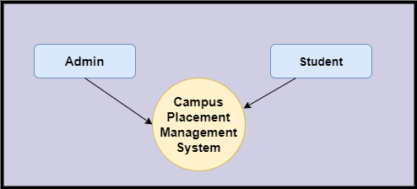

**Level 1 DFD**

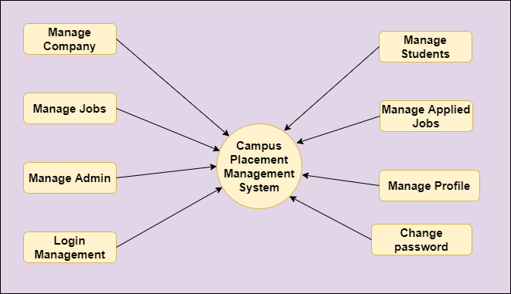

**Level 2 DFD – Admin**

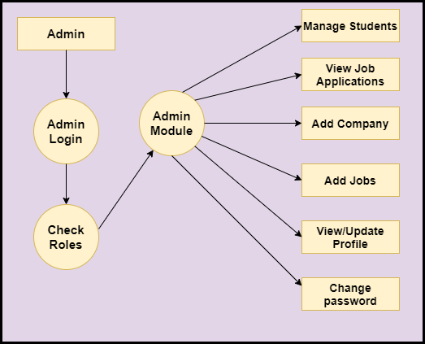

**Level 2 DFD – Student**

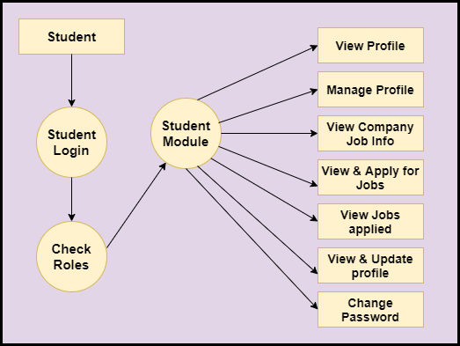

**Functional DFD:**

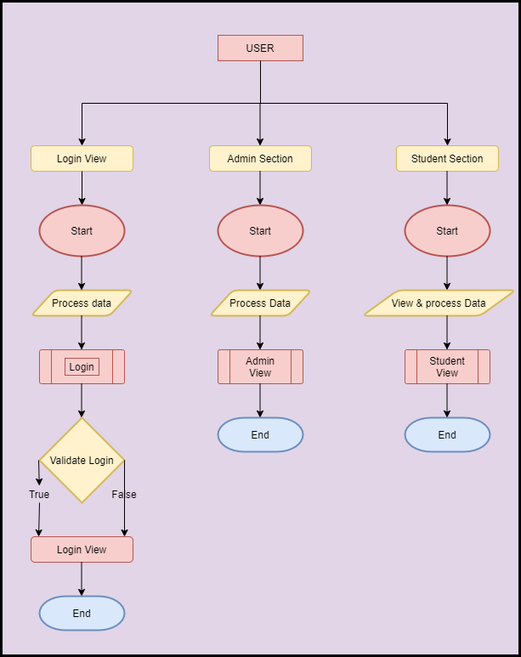

**Feasibility:**

This project will be developed on computer, so first check whether the technology is technically available or not. Now a day’s computer interaction with any job becomes common for any kind of job or work.

And because of increasing usage of Computer, Computer is also available with a variety of hardware. Vendors can fulfill any type of hardware requirement. The whole project is developed by some special tools or by using languages and databases, which are also available in a variety.

Preliminary investigation of a system examines the feasibility of a system that is useful to an organization. It is the first phase of system development.

The main objective of this phase is to identify the current deficiencies in the user’s environment and to determine which existing problem are going to be solve in proposed system and also which new function needs to be added in proposed system.

An important outcome of such preliminary investigation is to determine whether the system that will meet all needed requirements.

Thus, three tests are carried out on the system namely operation, technical and economical.

Any project is beneficial if and only satisfies the organization requirement. For any new system setup, it only meets to be communicated and work the other supporting system.

The new system meets all existing operations since it provides right information at a right time to the right user. A Leigh man can easily operate with the system. Technical Feasibility examines whether the technology needed is available and if it is available then it feasible to carry out all project activities.

The technical needs of a system include:

* The facility to produce outputs in a given time.
* Ability to process large number of transactions at a particular speed.
* Giving response to users under certain conditions.

The technology needed for our system is mainly:

* Latest version of browsers.
* Any operating system.

These technologies are available which helps to carry out the system efficiently. Economic feasibility of a system examines whether the finance is available for implementing the new system and whether the money spent is recoverable the satisfaction. The cost involves is in designing and developing a good investment for the organization. Thus, hardware requirements used for proposed system are very standard. Moreover, by making use of proposed system to carry out the work speedily will increase and also saves the valuable time of an organization.

In the proposed system the finance is highly required for the installation of the software’s which can also be recovered by implementing a better system.

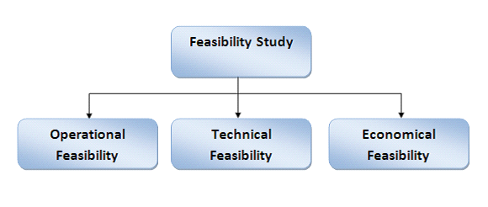

**Chapter-3**

**Design**



**Data dictionary**

**Data validation:**

Procedures are designed to detect errors in data at a lower level of detail. Data validations have been integrated in the system in almost every area where there is a possibility for the user to commit errors. The system will not recognize invalid data.

Whenever an invalid data is keyed in, the system immediately prompts the user and the user has to again key in the data and the system will accept the data only if the data is correct. Validations have been integrated where necessary.

The system is designed to be a user friendly one. In other words, the system has been designed to communicate effectively with the user. The system has been designed with pop-up menus.

**Different Type Of validation:**

* Data type validation;
* Range and constraint validation;
* Code and Cross-reference validation; and

Structured validation

**Coding**

**Implementation and Testing:**

**Black-Box Testing**:

Black Box Testing, also known as Behavioral Testing, is a software testing method in which the internal structure/ design/ implementation of the item being tested is not known to the tester. These tests can be functional or non-functional, though usually functional.

This can be following way:

* Input interfacing
* Processing
* Output interfacing

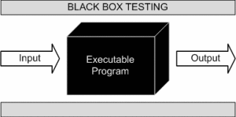

This method is named so because the software program, in the eyes of the tester, is like a black box; inside which one cannot see. This method attempts to find errors in the following categories:

* Incorrect or missing functions
* Interface errors
* Errors in data structures or external database access
* Behavior or performance errors
* Initialization and termination errors.

**White-Box Testing:**

White Box Testing, also known as Clear Box Testing, Open Box Testing, Glass Box Testing, Transparent Box Testing, Code-Based Testing or Structural Testing is a software testing method in which the internal structure/ design/ implementation of the item being tested is known to the tester.

The tester chooses inputs to exercise paths through the code and determines the appropriate outputs. Programming know-how and the implementation knowledge is essential.

White box testing is testing beyond the user interface and into the nitty-gritty of a system. This method is named so because the software program, in the eyes of the tester, is like a white/ transparent box; inside which one clearly sees.

**Limitations and Future Application of the Project**

**Futures Enhancement:**

* In future we can expand this project on the web.
* We can send them alerts to remind them of the interview dates.

**Limitation :**

* In this, we don’t block the students once it is placed. So we can also add the recruiter modules.

**Conclusion**

This project helps to replace the manual process of registration for the campus placement-related activity. The whole purpose lies here is to make the Campus placement process less tiresome and to make a database where we can have the students as well as the Jobs Information in one place and easily accessible when needed.

This project can be used by the colleges, Universities where the Placement coordinator can use this application and can manage the process of campus placement effortlessly. It also provides a platform for students to apply for their dream jobs.

This application is designed in such a way that any future modification can be done most easily.